Report On
AVL Rotation Demonstration

1. Introduction
An AVL tree is a self-balancing Binary Search Tree (BST). In a BST, smaller values are stored in the left subtree, while larger values are stored in the right subtree.
An AVL tree maintains balance by checking the balance factor of every node. If insertion makes a node unbalanced, rotations are performed to restore balance.
This project demonstrates four AVL tree rotations:
- LL (Left-Left) Rotation
- RR (Right-Right) Rotation
- LR (Left-Right) Rotation
- RL (Right-Left) Rotation

2. Problem Statement
To design and implement a C++ program to demonstrate the four types of AVL tree rotations: LL, RR, LR, and RL. The program allows the user to select a rotation case, displays the tree before and after rotation, identifies the balance factor of the unbalanced node, and verifies that inorder traversal remains unchanged after rotation. The objective is to understand how AVL rotations restore balance while preserving the Binary Search Tree property.

3. Objectives
- To understand the structure and properties of AVL trees.
- To demonstrate LL, RR, LR and RL rotations.
- To calculate and display the balance factor of nodes.
- To display the tree before and after rotation.
- To verify that inorder traversal remains unchanged after rotation.
- To implement a menu-driven C++ program.

4. Types of AVL Rotations
Rotation | Condition | Operation
LL | Insertion in left subtree of left child | Right rotation
RR | Insertion in right subtree of right child | Left rotation
LR | Insertion in right subtree of left child | Left rotation, then right rotation
RL | Insertion in left subtree of right child | Right rotation, then left rotation
5. Algorithm
- Start the program.
- Display the menu containing four rotation options and Exit.
- Accept the user's choice.
- Construct the three-node tree for the selected rotation case.
- Display the tree before rotation.
- Calculate and display the balance factor.
- Perform the appropriate rotation.
- Display the tree after rotation.
- In Version 2, perform inorder traversal before and after rotation.
- Compare both traversal sequences.
- Display the verification result.
- Repeat until the user selects Exit.
- Stop the program.

- Flowchart

┌─────────────┐
│ START │
└──────┬──────┘
│
┌──────▼──────┐
│ Initialize │
│ Empty AVL │
│ Tree │
└──────┬──────┘
│
┌─────────▼─────────┐
┌─────►│ Display Menu │◄────────────────────┐
│ └─────────┬─────────┘ │
│ │ │
│ ┌──────▼──────┐ │
│ │ Input Choice│ │
│ └──────┬──────┘ │
│ │ │
│ ┌──────▼──────┐ │
│ │ Choice = 1? │── Yes ──► LL Rotation │
│ └──────┬──────┘ Sequence │
│ │ No 30,20,10 │
│ ┌──────▼──────┐ │
│ │ Choice = 2? │── Yes ──► RR Rotation │
│ └──────┬──────┘ Sequence │
│ │ No 10,20,30 │
│ ┌──────▼──────┐ │
│ │ Choice = 3? │── Yes ──► LR Rotation │
│ └──────┬──────┘ Sequence │
│ │ No 30,10,20 │
│ ┌──────▼──────┐ │
│ │ Choice = 4? │── Yes ──► RL Rotation │
│ └──────┬──────┘ Sequence │
│ │ No 10,30,20 │
│ ┌──────▼──────┐ │
│ │ Choice = 5? │── Yes ──► END │
│ └──────┬──────┘ │
│ │ No │
│ ┌──────▼──────┐ │
│ │ Invalid │ │
│ │ Choice │ │
│ └──────┬──────┘ │
│ │ │
│ └───────────────────────────────┤
│ │
│ After Selecting Rotation │
│ │ │
│ ┌──────▼──────┐ │
│ │ Insert First│ │
│ │ Two Elements│ │
│ └──────┬──────┘ │
│ │ │
│ ┌──────▼──────┐ │
│ │ Display Tree│ │
│ │ Before Final│ │
│ │ Insertion │ │
│ └──────┬──────┘ │
│ │ │
│ ┌──────▼──────┐ │
│ │ Store Inorder│ │
│ │ Traversal │ │
│ └──────┬──────┘ │
│ │ │
│ ┌──────▼──────┐ │
│ │ Insert Third│ │
│ │ Element │ │
│ └──────┬──────┘ │
│ │ │
│ ┌──────▼──────┐ │
│ │ Calculate │ │
│ │ Height and │ │
│ │ Balance │ │
│ │ Factor │ │
│ └──────┬──────┘ │
│ │ │
│ ┌──────▼──────┐ │
│ │ Identify │ │
│ │ LL/RR/LR/RL │ │
│ └──────┬──────┘ │
│ │ │
│ ┌──────▼──────┐ │
│ │ Display │ │
│ │ Balance │ │
│ │ Factor │ │
│ └──────┬──────┘ │
│ │ │
│ ┌──────▼──────┐ │
│ │ Perform │ │
│ │ Rotation │ │
│ └──────┬──────┘ │
│ │ │
│ ┌──────▼──────┐ │
│ │ Display │ │
│ │ Balanced │ │
│ │ AVL Tree │ │
│ └──────┬──────┘ │
│ │ │
│ ┌──────▼──────┐ │
│ │ Perform │ │
│ │ Inorder │ │
│ │ Traversal │ │
│ └──────┬──────┘ │
│ │ │
│ ┌──────▼──────┐ │
│ │ Compare │ │
│ │ Inorder │ │
│ │ Traversal │ │
│ └──────┬──────┘ │
│ │ │
│ ┌──────▼──────┐ │
│ │ Verification│ │
│ │ Passed? │ │
│ └───┬─────┬────┘ │
│ Yes No │
│ │ │ │
│ ┌──────▼──┐ ┌──▼─────────┐ │
│ │ Display │ │ Display │ │
│ │ PASSED │ │ FAILED │ │
│ └──────┬──┘ └──┬─────────┘ │
│ │ │ │
└────────────┴────────┴───────────────────────────┘

- Source code

#include <iostream>
#include <algorithm>
#include <vector>
using namespace std;

struct Node
{
int key, height;
Node *left, *right;

Node(int k)
{
key = k;
height = 1;
left = right = NULL;
}
};

int h(Node *n)
{
return n == NULL ? 0 : n->height;
}

int bf(Node *n)
{
return n == NULL ? 0 : h(n->left) - h(n->right);
}

Node* rightRotate(Node *y)
{
Node *x = y->left;
Node *t = x->right;

x->right = y;
y->left = t;

y->height = 1 + max(h(y->left), h(y->right));
x->height = 1 + max(h(x->left), h(x->right));

return x;
}

Node* leftRotate(Node *x)
{
Node *y = x->right;
Node *t = y->left;

y->left = x;
x->right = t;

x->height = 1 + max(h(x->left), h(x->right));
y->height = 1 + max(h(y->left), h(y->right));

return y;
}

void inorder(Node *root, vector<int> &v)
{
if (root == NULL)
return;

inorder(root->left, v);
v.push_back(root->key);
inorder(root->right, v);
}

void display(Node *root, int space = 0)
{
if (root == NULL)
return;

space += 6;
display(root->right, space);

cout << endl;
for (int i = 6; i < space; i++)
cout << " ";

cout << root->key << "(BF=" << bf(root) << ")" << endl;
display(root->left, space);
}

Node* insert(Node *root, int key, bool show = false)
{
if (root == NULL)
return new Node(key);

if (key < root->key)
root->left = insert(root->left, key, show);
else if (key > root->key)
root->right = insert(root->right, key, show);
else
return root;

root->height = 1 + max(h(root->left), h(root->right));

int balance = bf(root);

if (balance > 1 && key < root->left->key)
{
if (show)
cout << "\nLL case at node " << root->key
<< ", BF = " << balance << endl;
return rightRotate(root);
}

if (balance < -1 && key > root->right->key)
{
if (show)
cout << "\nRR case at node " << root->key
<< ", BF = " << balance << endl;
return leftRotate(root);
}

if (balance > 1 && key > root->left->key)
{
if (show)
cout << "\nLR case at node " << root->key
<< ", BF = " << balance << endl;
root->left = leftRotate(root->left);
return rightRotate(root);
}

if (balance < -1 && key < root->right->key)
{
if (show)
cout << "\nRL case at node " << root->key
<< ", BF = " << balance << endl;
root->right = rightRotate(root->right);
return leftRotate(root);
}

return root;
}

void runDemo(int choice)
{
Node *root = NULL;
int a[3];

if (choice == 1)
{
a[0] = 30; a[1] = 20; a[2] = 10;
}
else if (choice == 2)
{
a[0] = 10; a[1] = 20; a[2] = 30;
}
else if (choice == 3)
{
a[0] = 30; a[1] = 10; a[2] = 20;
}
else
{
a[0] = 10; a[1] = 30; a[2] = 20;
}

cout << "\nTree before the final insertion:\n";
root = insert(root, a[0]);
root = insert(root, a[1]);
display(root);

vector<int> before;
inorder(root, before);

cout << "\nInserting " << a[2] << "...\n";
root = insert(root, a[2], true);

cout << "\nTree after insertion and rotation:\n";
display(root);

vector<int> after;
inorder(root, after);

cout << "\nFinal inorder traversal: ";
for (int i = 0; i < (int)after.size(); i++)
cout << after[i] << " ";

vector<int> expected;
expected.push_back(a[0]);
expected.push_back(a[1]);
expected.push_back(a[2]);
sort(expected.begin(), expected.end());

if (after == expected)
cout << "\nInorder verification: PASSED\n";
else
cout << "\nInorder verification: FAILED\n";
}

int main()
{
int choice;
do
{
cout << "\n===== AVL ROTATION DEMONSTRATION =====\n";
cout << "1. LL Rotation (30, 20, 10)\n";
cout << "2. RR Rotation (10, 20, 30)\n";
cout << "3. LR Rotation (30, 10, 20)\n";
cout << "4. RL Rotation (10, 30, 20)\n";
cout << "5. Exit\n";
cout << "Enter your choice: ";
cin >> choice;

if (choice >= 1 && choice <= 4)
runDemo(choice);
else if (choice == 5)
cout << "Program ended.\n";
else
cout << "Invalid choice!\n";

} while (choice != 5);

return 0;
}
Output :

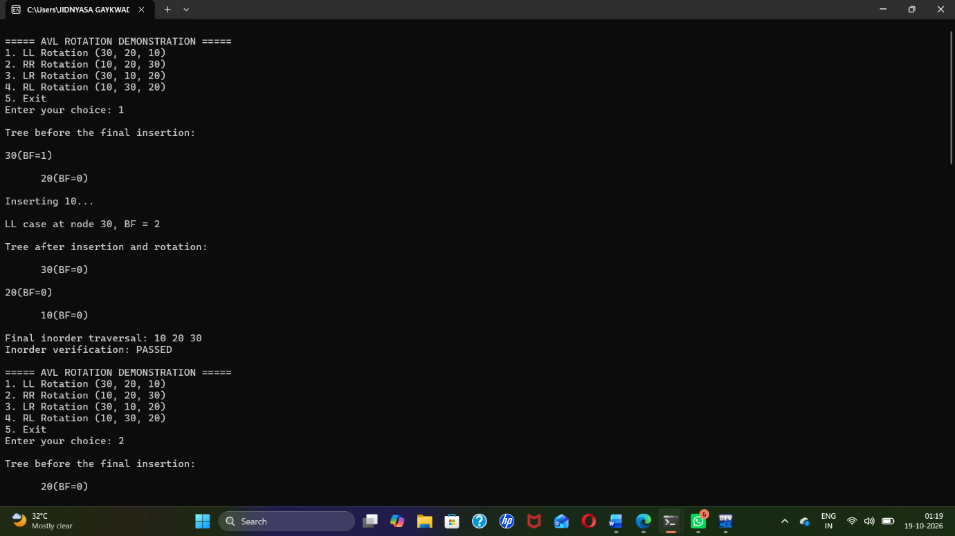

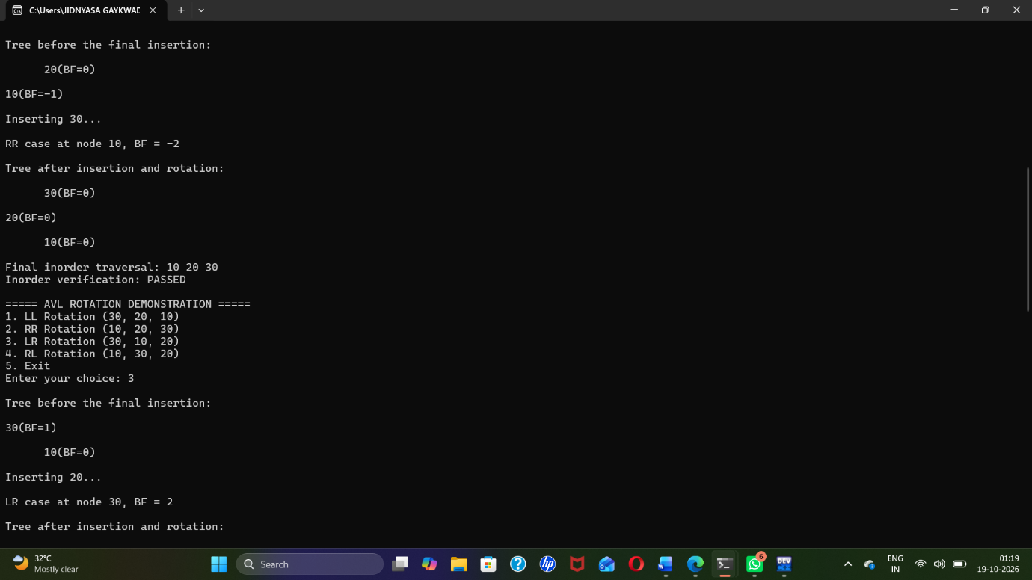

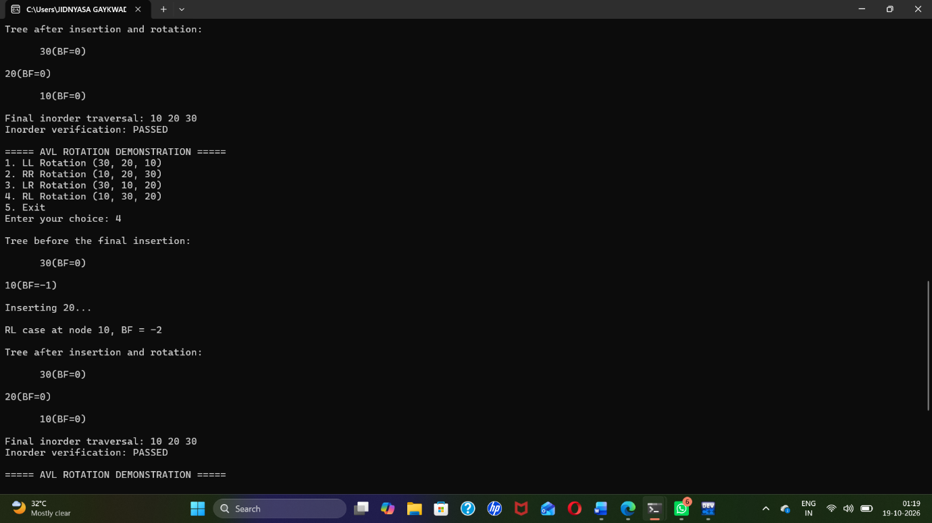

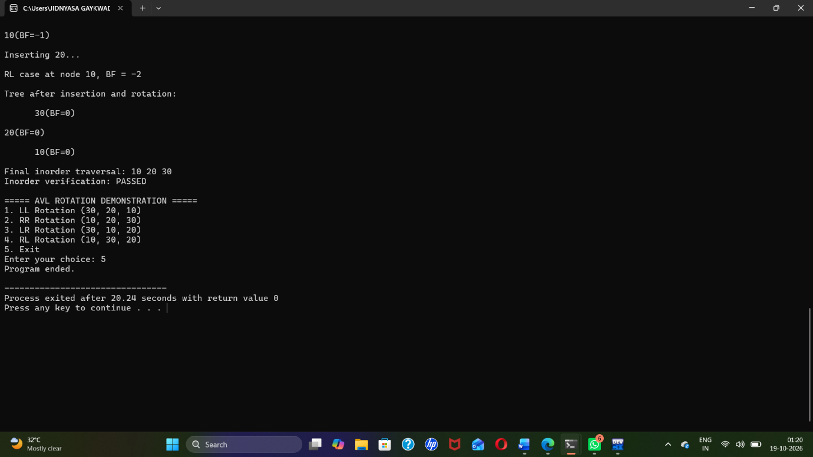
9. Advantages
- Demonstrates all four AVL rotation cases.
- Helps visualize changes in tree structure.
- Displays balance factors for the nodes.
- Uses a menu-driven interface.
- Version 2 checks whether inorder traversal is preserved.
- Supports learning of Binary Search Trees and self-balancing trees.
10. Conclusion
The AVL Rotation Demonstration project explains how LL, RR, LR, and RL rotations restore balance in an AVL tree. Version 1 demonstrates each rotation and displays the tree before and after the operation. Version 2 adds inorder traversal verification to confirm that rotations change the tree structure without changing the sorted order of the keys. Thus, the project demonstrates how AVL rotations preserve the Binary Search Tree property while restoring balance.

